Testing

1-What is Testing
# Source: Chatgpt (GPT-5-Standard) at [8/12/2025]
In software engineering, testing is the process of evaluating a software application or system to find defects (bugs), verify that it works as intended, and ensure it meets the specified requirements before it is delivered to users.
In simpler terms:
It’s like a quality check for software — making sure it does what it’s supposed to do, works reliably, and doesn’t break in unexpected ways.

2-Main Goals of Software Testing
# Source: Chatgpt (GPT-5-Standard) at [8/12/2025]
- Verify functionality – Does the software do what the requirements say?
- Detect defects – Find and fix bugs before users encounter them.
- Ensure quality – Improve reliability, performance, and usability.
- Validate requirements – Confirm the product matches the client’s needs.

3-Types of Software Testing
# Source: Chatgpt (GPT-5-Standard) at [8/12/2025]
1. Based on Approach
- Manual Testing – Humans perform tests without automation tools.
- Automated Testing – Scripts and tools automatically run tests.
2. Based on Purpose
- Functional Testing – Checks what the system does.
Example: Unit Testing, Integration Testing, System Testing, Acceptance Testing.
- Non-Functional Testing – Checks how well the system works.
Example: Performance Testing, Security Testing, Usability Testing.

4-Testing Stages in Development
# Source: Chatgpt (GPT-5-Standard) at [8/12/2025]
- Unit Testing – Test small, individual pieces of code.
- Integration Testing – Test how different parts work together.
- System Testing – Test the complete application as a whole.
- Acceptance Testing – Final check before release, often done with the customer.

💡 Key Point:
Testing doesn’t guarantee software is 100% bug-free — it reduces the risk of defects and increases confidence that the system will work correctly in real use.

5-why there are Software testing
# Source: Chatgpt (GPT-5-Standard) at [8/12/2025]
Software testing exists because humans (and the code we write) are far from perfect — and mistakes in software can cost money, damage trust, or even endanger lives.
Here’s a clear breakdown:

I. Why There Is Software Testing
# Source: Chatgpt (GPT-5-Standard) at [8/12/2025]
We test software to:
- Find bugs before users do – Prevent crashes, incorrect results, or security holes.
- Ensure it meets requirements – Verify that what was built matches what was asked for.
- Improve reliability – Confirm the software works under expected (and unexpected) conditions.
- Reduce risks – Catch issues that could cause legal, financial, or safety problems.
- Maintain quality over time – Prevent new updates from breaking existing features.
Think of it as the “quality checkpoint” before letting software go into the wild.

II. How Software Testing Was Discovered / Made
# Source: Chatgpt (GPT-5-Standard) at [8/12/2025]
Software testing wasn’t born as a formal concept — it evolved as computers became complex:
- 1940s–1950s – Early computers were programmed on punch cards; errors were so costly in time that programmers checked outputs manually.
- 1960s – With the rise of larger systems, IBM and others began formalizing debugging and verification methods.
- 1970s–1980s – “Software engineering” became a field; structured testing methods (unit, integration, system testing) were documented.
- 1990s–2000s – Automated testing tools emerged as software grew bigger and release cycles got shorter.
- Today – Testing is part of SDLC (Software Development Life Cycle) and CI/CD pipelines, using automation, AI-based testing, and continuous monitoring.

III. How We “Make” Software Testing
# Source: Chatgpt (GPT-5-Standard) at [8/12/2025]
We create testing strategies and methods by:
- Defining what to test – Based on requirements, user stories, or risk assessment.
- Choosing test types – Unit tests, integration tests, system tests, UI tests, performance tests, security tests, etc.
- Designing test cases – Step-by-step checks of inputs, actions, and expected results.
- Automating where possible – Using tools like Selenium, JUnit, or Playwright.
- Measuring coverage – Ensuring all important paths and edge cases are checked.
- Iterating – Updating tests as software changes.

6-is testing need management
# Source: Chatgpt (GPT-5-Standard) at [8/12/2025]
Yes — software testing absolutely needs management, and in fact, there’s an entire discipline called Test Management dedicated to it.

Why Testing Needs Management
# Source: Chatgpt (GPT-5-Standard) at [8/12/2025]
Without management, testing can become:
- Unorganized → tests may be missed or duplicated.
- Inefficient → testers spend time on low-priority areas while critical parts go unchecked.
- Unmeasurable → no way to know if you’re truly ready for release.

What Test Management Involves
# Source: Chatgpt (GPT-5-Standard) at [8/12/2025]
- Planning – Deciding the scope, objectives, resources, and schedule for testing.
- Organizing – Assigning roles and responsibilities (testers, tools, environments).
- Controlling – Monitoring progress, managing risks, and making adjustments.
- Tracking & Reporting – Measuring results (bug counts, coverage, pass rates) and sharing them with stakeholders.

Benefits of Test Management
# Source: Chatgpt (GPT-5-Standard) at [8/12/2025]
- Clear priorities – Focus on what matters most.
- Better coverage – Reduce the risk of missing critical defects.
- Efficient use of resources – Right people, right tools, right time.
- Transparency – Everyone knows the status of testing and readiness for release.

💡 In professional projects, Test Management is usually handled by a Test Manager or QA Lead, often using tools like Jira, TestRail, or Zephyr to coordinate and track testing activities.

7-what is testing tools
# Source: Chatgpt (GPT-5-Standard) at [8/12/2025]
Testing tools are software applications or platforms that help testers plan, execute, manage, and automate the testing process.
They make testing faster, more accurate, and more organized compared to doing everything manually.

1. Why We Use Testing Tools
# Source: Chatgpt (GPT-5-Standard) at [8/12/2025]
- Save time – Automate repetitive checks.
- Improve accuracy – Reduce human error.
- Track progress – Measure coverage, pass/fail rates, bug counts.
- Handle complexity – Test large systems or multiple platforms efficiently.

2. Types of Testing Tools & Examples
# Source: Chatgpt (GPT-5-Standard) at [8/12/2025]
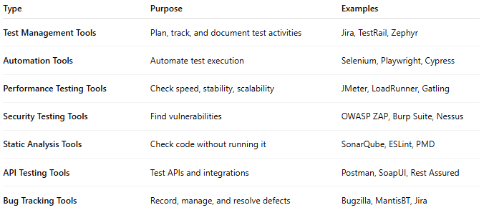
Type | Purpose | Examples
Test Management Tools | Plan, track, and document test activities | Jira, TestRail, Zephyr
Automation Tools | Automate test execution | Selenium, Playwright, Cypress
Performance Testing Tools | Check speed, stability, scalability | JMeter, LoadRunner, Gatling
Security Testing Tools | Find vulnerabilities | OWASP ZAP, Burp Suite, Nessus
Static Analysis Tools | Check code without running it | SonarQube, ESLint, PMD
API Testing Tools | Test APIs and integrations | Postman, SoapUI, Rest Assured
Bug Tracking Tools | Record, manage, and resolve defects | Bugzilla, MantisBT, Jira

3. Where Testing Tools Fit in the Process
# Source: Chatgpt (GPT-5-Standard) at [8/12/2025]
- Static Testing Phase → Static analysis tools (e.g., SonarQube)
- Dynamic Testing Phase → Automation, performance, security tools
- Management Phase → Test management and bug tracking tools

8-Essentials Skills and Good practices in Testing
# Source: Chatgpt (GPT-5-Standard) at [8/12/2025]
Here’s a compact but complete breakdown of Essential Skills and Good Practices in software testing, so it’s easy to apply in real projects.

1. Essential Skills in Testing 🛠️

Technical Skills
# Source: Chatgpt (GPT-5-Standard) at [8/12/2025]
- Understanding of SDLC & STLC → Know how testing fits in software development and testing life cycles.
- Test Design Techniques → Equivalence partitioning, boundary value analysis, decision tables, state transition testing, etc.
- Automation Skills → Using tools like Selenium, Cypress, Playwright, JUnit, or Postman.
- Knowledge of Databases → Basic SQL queries to validate backend data.
- API Testing → Understanding REST, SOAP, JSON, XML, and how to verify them.
- Debugging & Troubleshooting → Ability to pinpoint root causes with logs, breakpoints, and error messages.

Analytical Skills
# Source: Chatgpt (GPT-5-Standard) at [8/12/2025]
- Requirement Analysis → Spot ambiguities, missing details, and inconsistencies.
- Risk Analysis → Identify high-priority areas that must be tested thoroughly.

Soft Skills
# Source: Chatgpt (GPT-5-Standard) at [8/12/2025]
- Attention to Detail → Catching subtle defects that others might miss.
- Communication → Writing clear bug reports and test documentation.
- Critical Thinking → Asking “what if” and exploring edge cases.
- Team Collaboration → Working effectively with developers, product managers, and other testers.

2. Good Practices in Testing ✅
# Source: Chatgpt (GPT-5-Standard) at [8/12/2025]
- Start Testing Early
  - Follow Shift-Left Testing — involve testers in requirements and design phases.
- Write Clear Test Cases
  - Each case should have a clear objective, steps, expected result, and actual result.
- Test Based on Risk
  - Focus more on features that are critical to business or prone to failure.
- Automate Where Useful
  - Automate repetitive regression tests, but keep exploratory testing manual.
- Use Realistic Test Data
  - Avoid only using dummy values; simulate real-world usage as much as possible.
- Log Bugs Clearly
  - Include steps to reproduce, screenshots, and environment details.
- Maintain a Test Environment
  - Keep it stable and close to production conditions.
- Measure and Improve
  - Track metrics like defect density, test coverage, pass/fail rate to identify improvement areas.
- Perform Exploratory Testing
  - Go beyond scripted tests to find unexpected issues.
- Retest and Regression Test
  - Always recheck fixed defects and ensure new changes haven’t broken existing functionality.

9-Whole Team Approach
# Source: Chatgpt (GPT-5-Standard) at [8/12/2025]
Whole Team Approach in testing means everyone involved in the software development project shares responsibility for quality — not just the testers or QA team.
Instead of thinking “testing is the tester’s job,” the whole team (developers, testers, business analysts, product owners, designers, etc.) collaborates to prevent defects early and ensure the product meets quality goals.

Key Points
# Source: Chatgpt (GPT-5-Standard) at [8/12/2025]
- Quality is a shared responsibility, not a separate phase at the end.
- Testing activities are integrated throughout the Software Development Life Cycle (SDLC).
- Encourages communication between roles to detect issues early.
- Fits naturally into Agile and DevOps workflows.

Example
# Source: Chatgpt (GPT-5-Standard) at [8/12/2025]
Imagine you’re building an online shopping cart:
- Business Analyst: Clearly defines requirements and acceptance criteria.
- Developer: Writes code and also writes automated unit tests.
- Tester: Designs exploratory and functional test cases.
- UX Designer: Ensures the interface is intuitive and tests prototypes with users.
- Product Owner: Reviews features and gives feedback early.
- DevOps Engineer: Sets up continuous integration and testing pipelines.
All of them work together, give feedback, and adjust before the software is released.

Benefits
# Source: Chatgpt (GPT-5-Standard) at [8/12/2025]
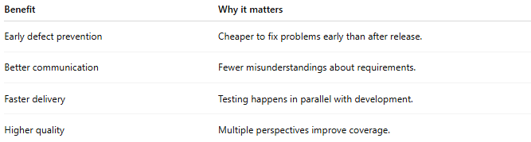
Benefit | Why it matters
Early defect prevention | Cheaper to fix problems early than after release.
Better communication | Fewer misunderstandings about requirements.
Faster delivery | Testing happens in parallel with development.
Higher quality | Multiple perspectives improve coverage.

💡 In short:
Whole Team Approach = “It’s our product, so it’s our quality responsibility.”

If you like, I can also explain how Whole Team Approach connects with “Independence of Testing” — they seem opposite at first but actually complement each other.

10-Independence of Testing
# Source: Chatgpt (GPT-5-Standard) at [8/12/2025]
Independence of Testing means that the people who test the software should be as separate as possible from the people who developed it — to avoid bias and catch more defects.
When developers test their own code, they might:
- Assume it works as intended (confirmation bias).
- Overlook defects because they know “how it’s supposed to work.”
- Skip testing unusual scenarios.
Independent testers bring fresh eyes and a different perspective, which increases the chance of finding issues.

Levels of Testing Independence (from least to most independent)
# Source: Chatgpt (GPT-5-Standard) at [8/12/2025]
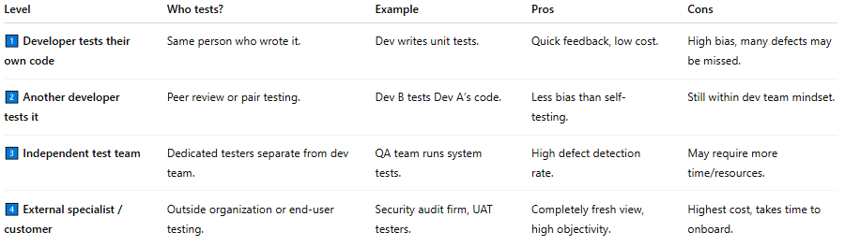
Level | Who tests? | Example | Pros | Cons
1️⃣ Developer tests their own code | Same person who wrote it. | Dev writes unit tests. | Quick feedback, low cost. | High bias, many defects may be missed.
2️⃣ Another developer tests it | Peer review or pair testing. | Dev B tests Dev A’s code. | Less bias than self-testing. | Still within dev team mindset.
3️⃣ Independent test team | Dedicated testers separate from dev team. | QA team runs system tests. | High defect detection rate. | May require more time/resources.
4️⃣ External specialist / customer | Outside organization or end-user testing. | Security audit firm, UAT testers. | Completely fresh view, high objectivity. | Highest cost, takes time to onboard.

Example
# Source: Chatgpt (GPT-5-Standard) at [8/12/2025]
If you build a login feature:
- Not independent: You code it and test it yourself.
- More independent: Your teammate tests it.
- Fully independent: A QA tester who wasn’t involved in coding tests it.

✅ Key Idea:
The more independent the testing, the better the chances of catching hidden defects — but the higher the cost and effort.

